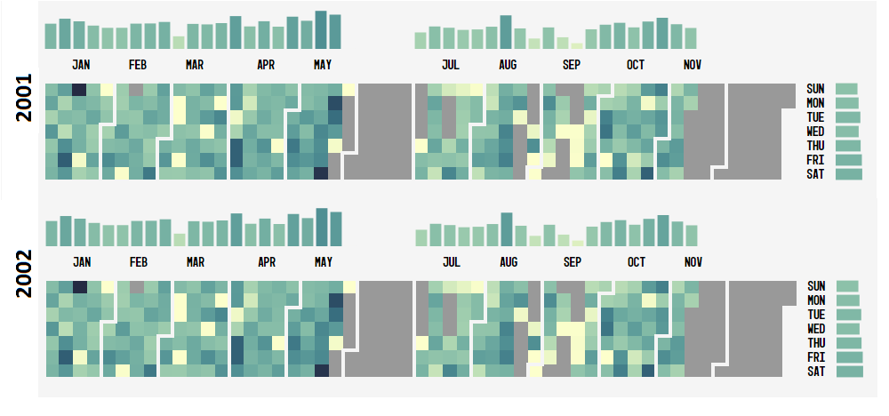Part A - Requirements:

1. Data from January 2001 to December 2001 (total emails by each day)

|  |  |
| --- | --- |
| Date | Total Emails = Sent+Received+FW+CC |
| Week 1 | 808 |
| Week 2 | 894 |
| Week 3 | 866 |
| Week 4 | 872 |
| - |  |
| - |  |
| Week 52 | 823 |

2. Need both CSV and json format

Set2_File1.csv / Set2_File1.json

3. SQL query

**select** *WEEK*(**date**) **AS** weekNumber , *count*(*\**) **as** totalEmails  
**FROM** message  
**WHERE** *YEAR*(**date**) = 2001  
**GROUP BY** *WEEK*(**date**)

Part B - Requirements:

1. Data from January 2001 to December 2001 (total emails by each day)

|  |  |
| --- | --- |
| Date | Total Emails = Sent+Received+FW+CC |
| Sun | 808 |
| Mon | 894 |
| Tue | 866 |
| Wed | 872 |
| - |  |
| - |  |
| Sat | 823 |

2. Need both CSV and json format

Set2_File2.csv / Set2_File2.json

3. SQL query

**select** *DAYNAME*(**date**) **AS** dayName , *count*(*\**) **as** totalEmails  
**FROM** message  
**WHERE** *YEAR*(**date**) = 2001  
**GROUP BY** *DAYNAME*(**date**)  
**ORDER BY** *DAYOFWEEK*(**date**)